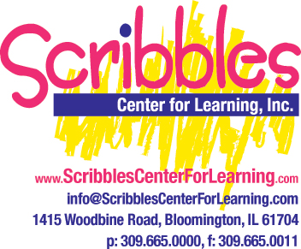

Celebrating Your Child’s Birthday at Scribbles:

We recognize that your child’s birthday is a fun and exciting time for your family and your classroom teacher will make certain that your child has a special day!

If you choose to bring a birthday snack, please make certain to check with your child’s teacher to determine what day of the week and time of day is best for you to bring it and how many children will be in attendance that day. Snacks must be healthy, store-bought, pre-packaged, and contain no peanuts or peanut products. Anything listed below is acceptable to bring:

Approved Birthday Snacks:

Yogurt/Go-Gurt
Frozen Yogurt (Vanilla or Plain)
Cheese Sticks/String Cheese
Carrots/Celery with Ranch Dressing
Rice Cakes
Fresh Fruit
Applesauce
Italian Ice
Dried Fruit
Fruit Leathers (Natural Value)
100% Fruit Juice Popsicles (Breyers/Dole)
Cheerios (other varieties like Fruity Cheerios are fine – no Honey Nut)
Frosted Mini Wheats
Cereal Bars

Due to food allergies, sugar content, and potential choking hazards, goodie bags, party favors, and candy are not allowed and will not be distributed.

If you have any questions regarding appropriate birthday snacks or policies, please ask your classroom teacher or an administrator.

